**Soap UI MiniProject**

1. **Creating Test Suite by adding Test Cases:**

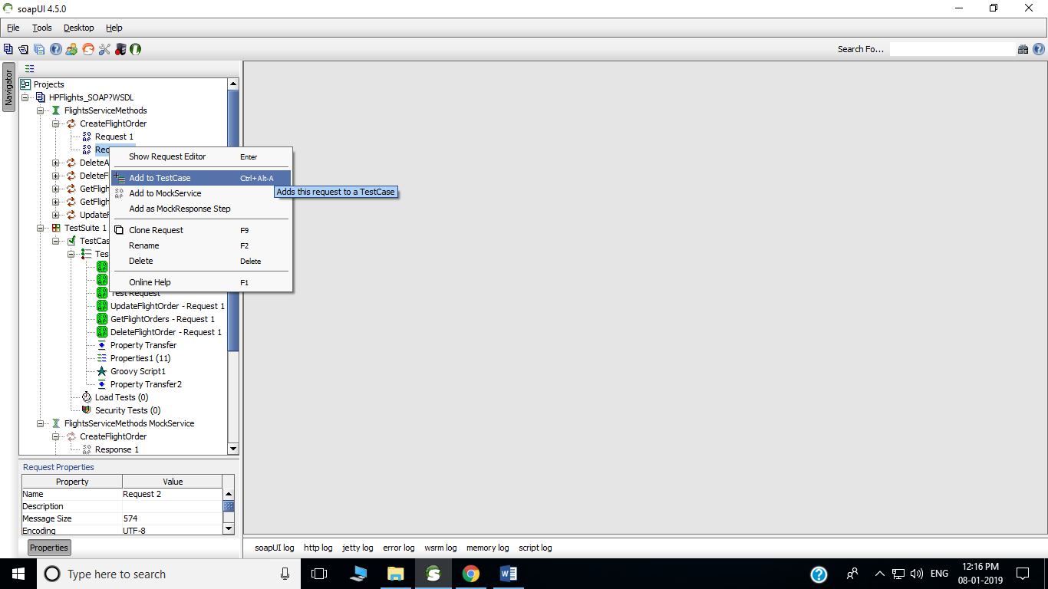**Step 1**. Right click on the CreateFlightOrder and select add to TestCase.

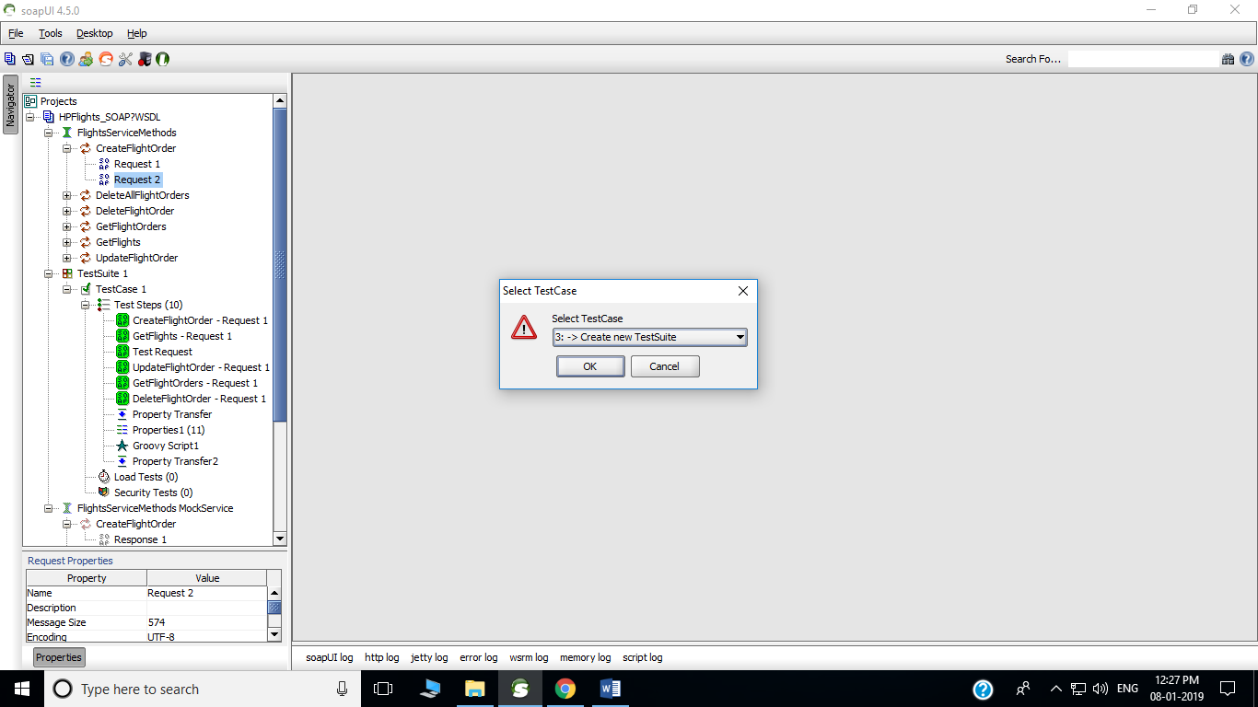**Step 2**. Click ok to create test suite.

**Step 3**. Enter a name and Click ok to create test suite.

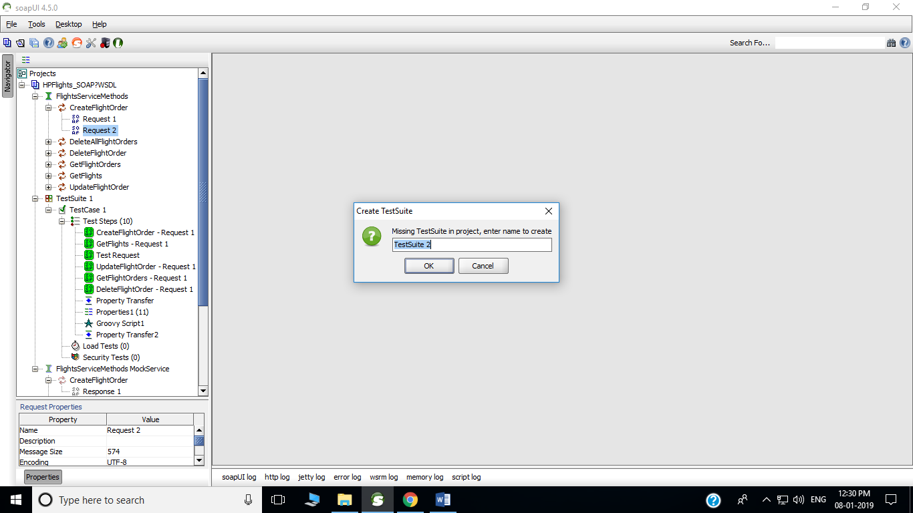

**Step 4**. Enter a test case name and Click ok to create test case.

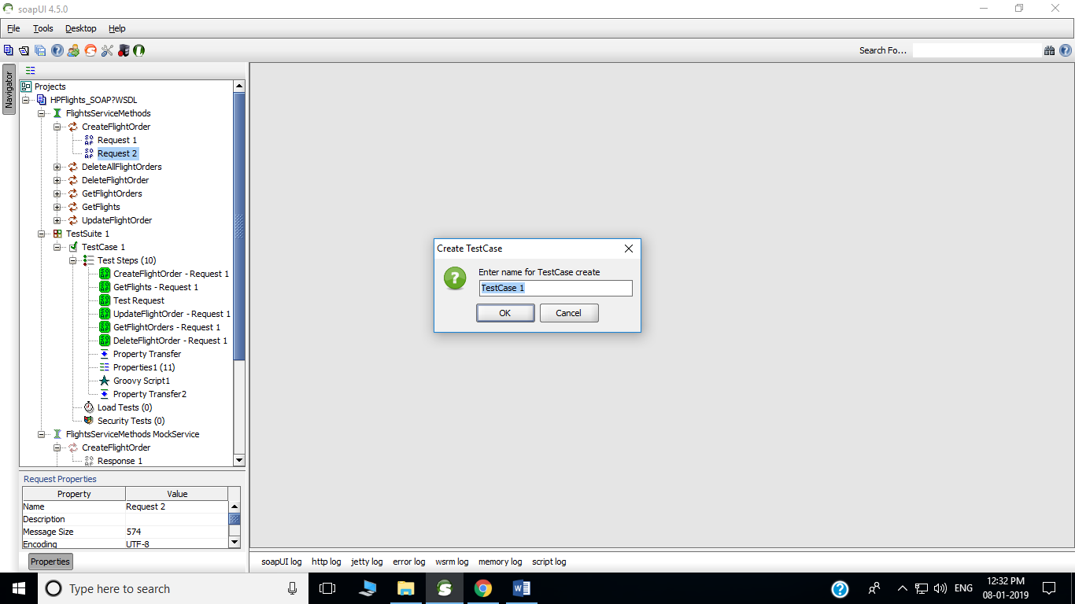

**Step 5**. Select checkboxes and Click ok.

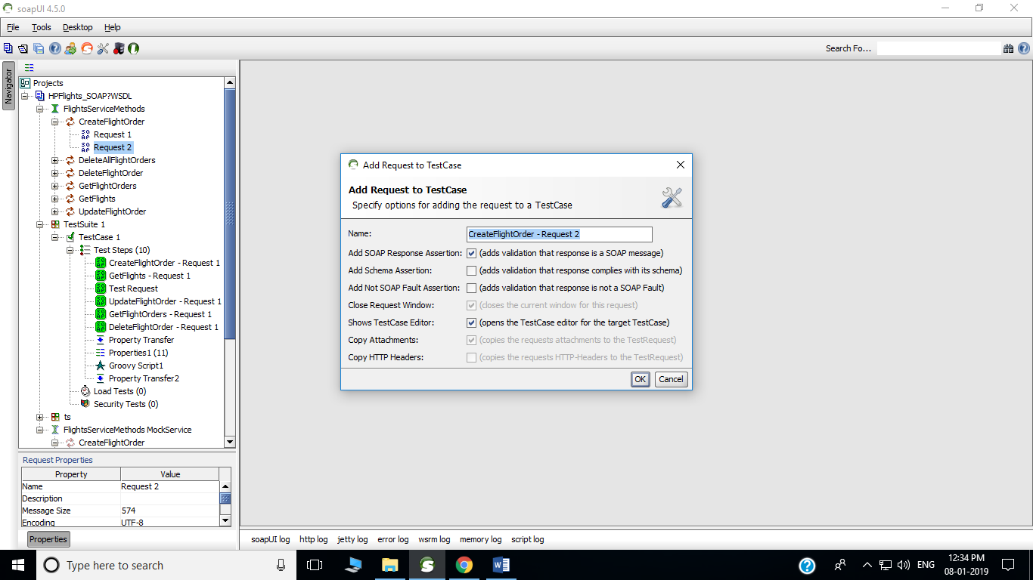

Below Window will appear after creating a test case. And similarly test case can be created for the all soap requests.

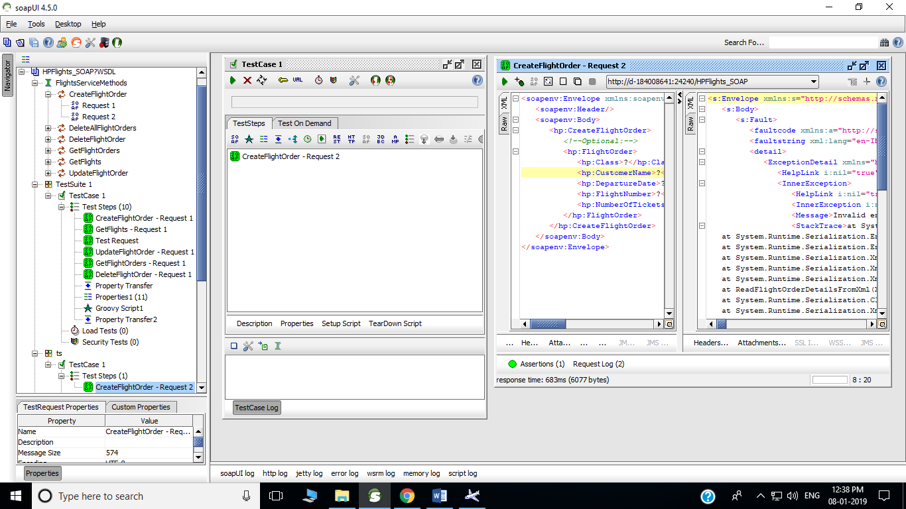

1. **Execute Test Cases:**

**Step 1**. Double click on TestCase 1 and this window will open.

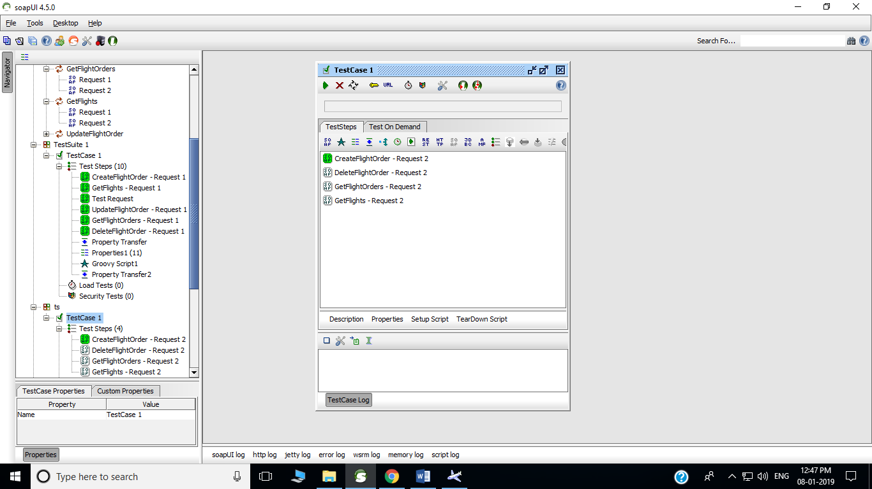

**Step 2**. Select the play button from TestCase1 window.

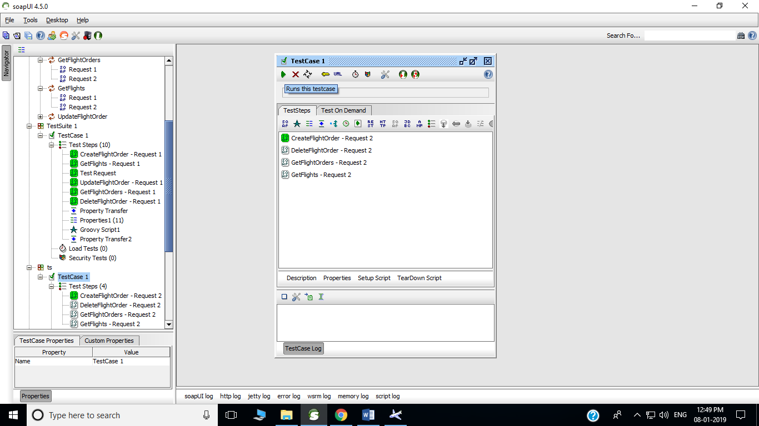

**Step 3**.This will excute the testcase and green color is shown if the test case passed and it shows red if it fails.

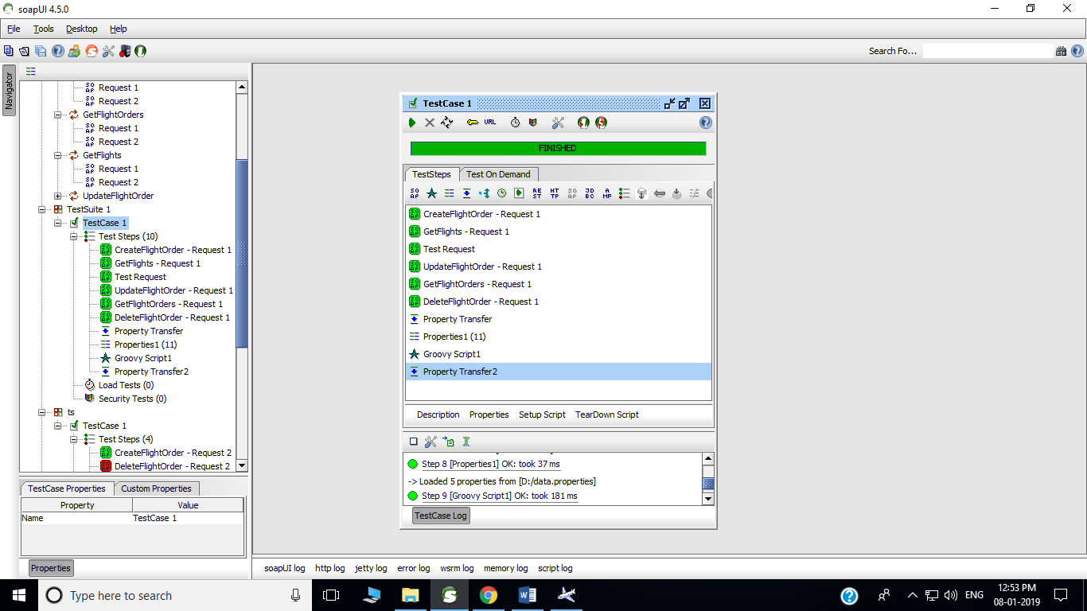

1. **Parameterization:**

**Step 1**. Create a data.properties file for parameterization.

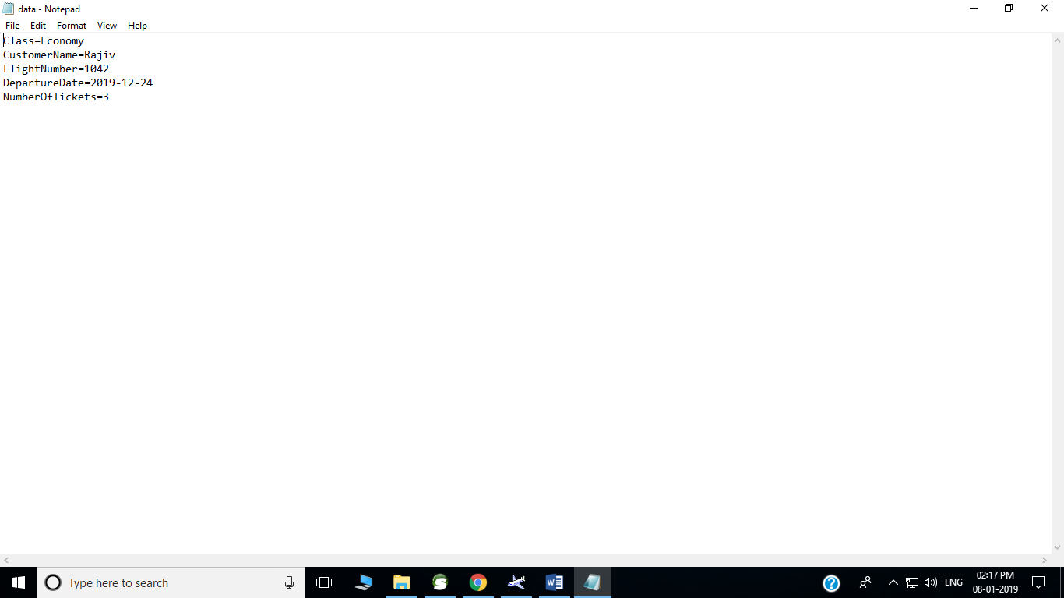

**Step 2** .Right click in the window of the testcase1 and select properties.

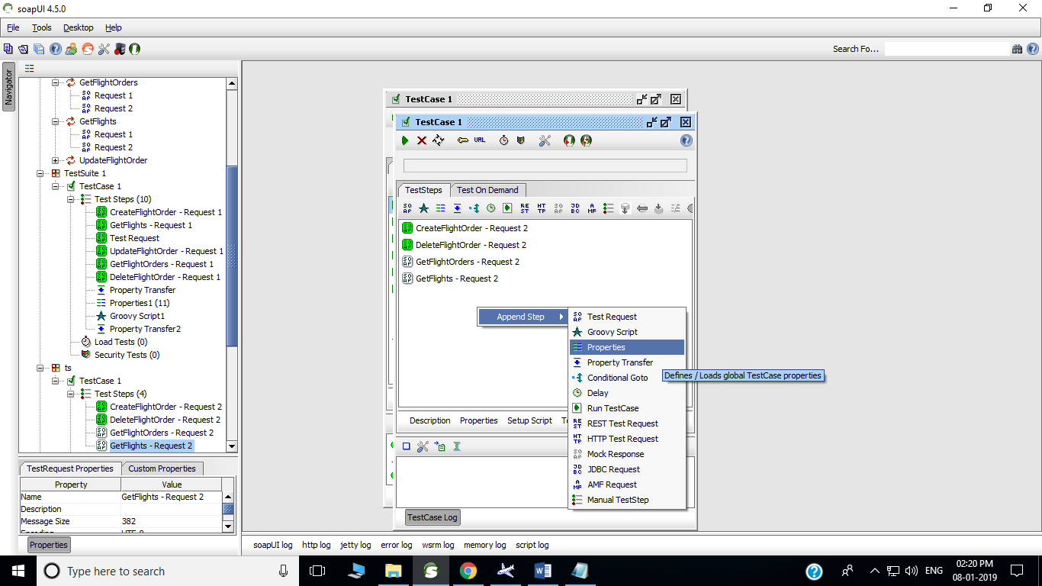

**Step 3**. Enter the name as properties for new steps and click Ok.

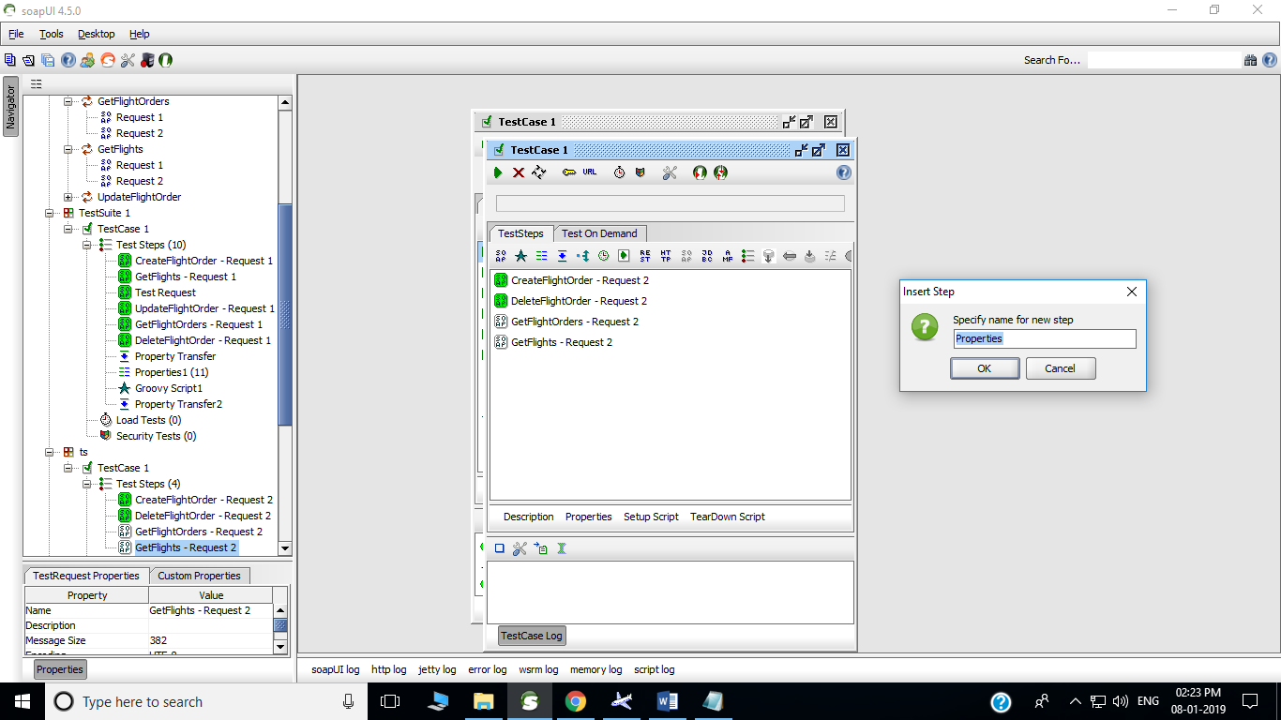

**Step 4**. Select the properties source files as shown.

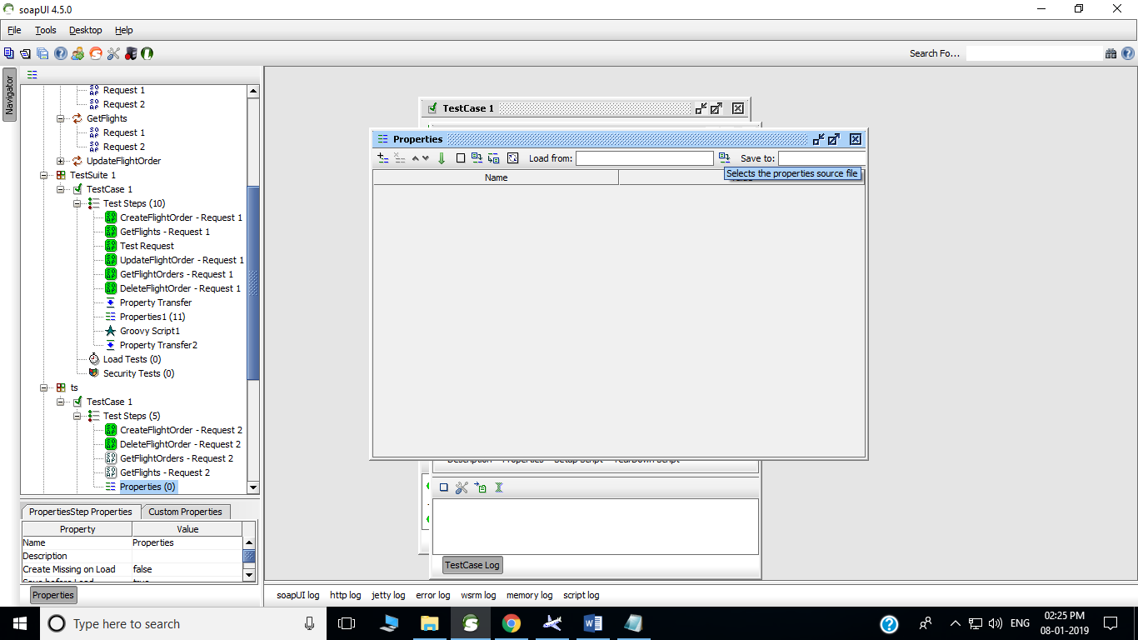

**Step 5**. Select the properties source files as shown.

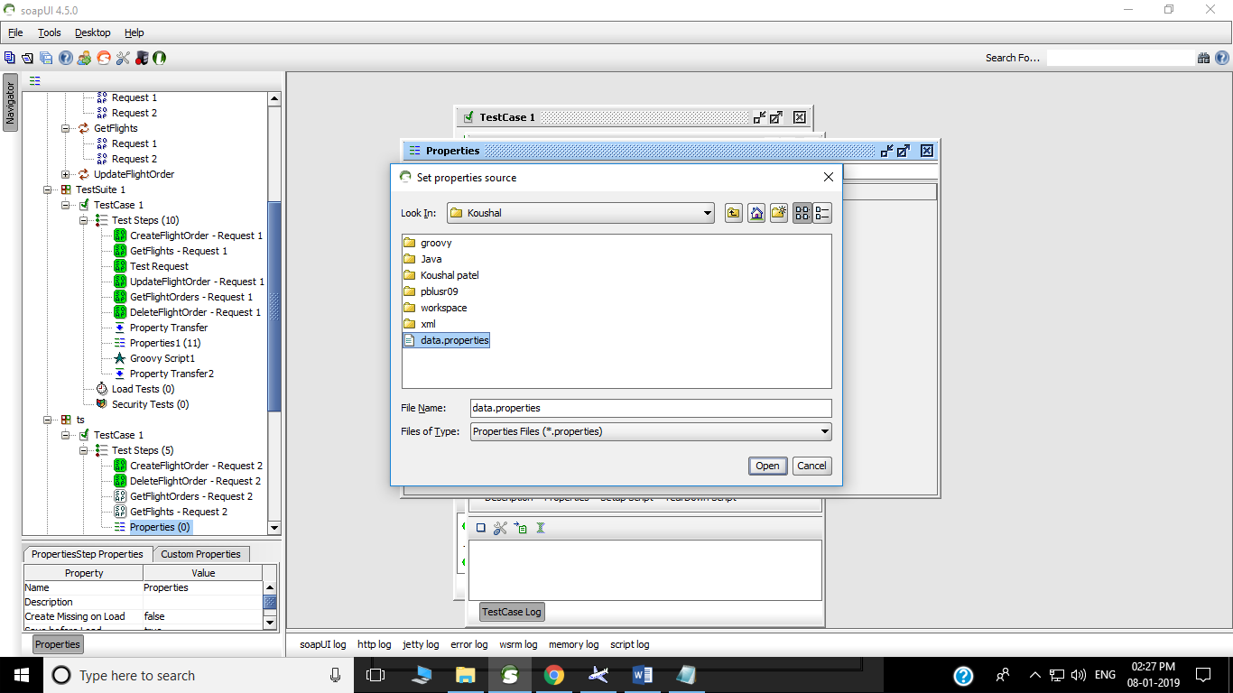

This will prompt all properties from the source files.

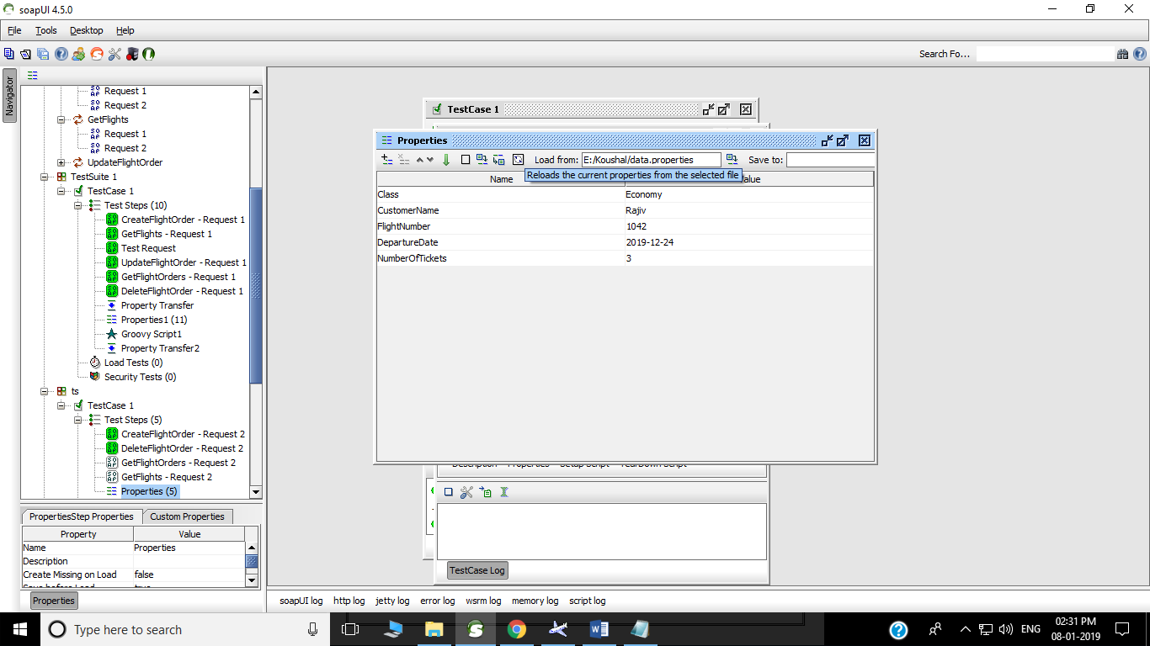

**Step 6**. Open GetFlights-request1 window.

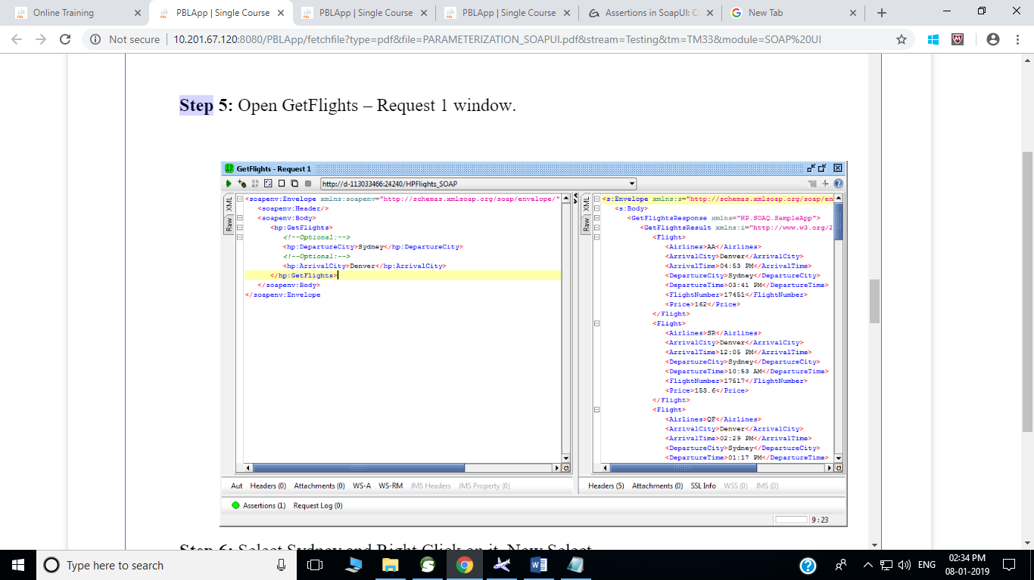

**Step 7.** Select Paris and right click on it and select get Data-> Step : Properties -> Property [DepartureCity].

Similarly select London and right click on it and select get Data-> Step : Properties -> Property [ArrivalCity].

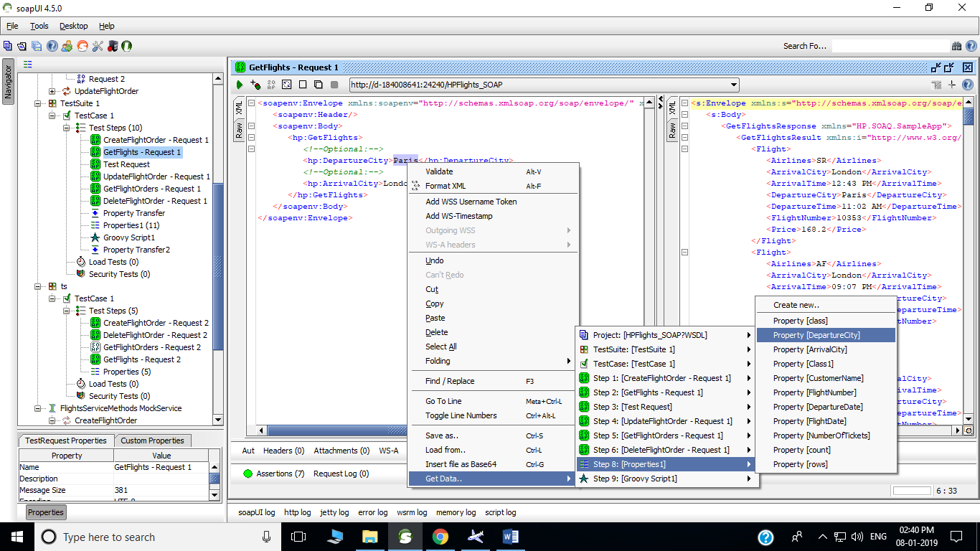

**Step 8**. Both the parameters will be parameterized. Now click on run and result will be shown for parameterized value.

